**Crime Data Proposal**

Mario Cosby, Reena Desai, Tim St. Onge, Jimmy White

3.28.2019

**Topic and Rationale:**

We have decided to study DC crime data. Mario and Reena did the ETL project on the public crime dataset for the District of Columbia. We think it would be interesting to use our skills in Leaflet and interactive dashboards to create dropdowns. We think that we will have a few dropdowns to filter out crime data: 1) type of crime 2) ward 3) time 4) time of day.

**Link to Dataset and screenshot of metadata:**

Github for ETL project: <https://github.com/r33nava/ETLProject>

Crime data: <http://opendata.dc.gov/datasets/crime-incidents-in-2019/data>

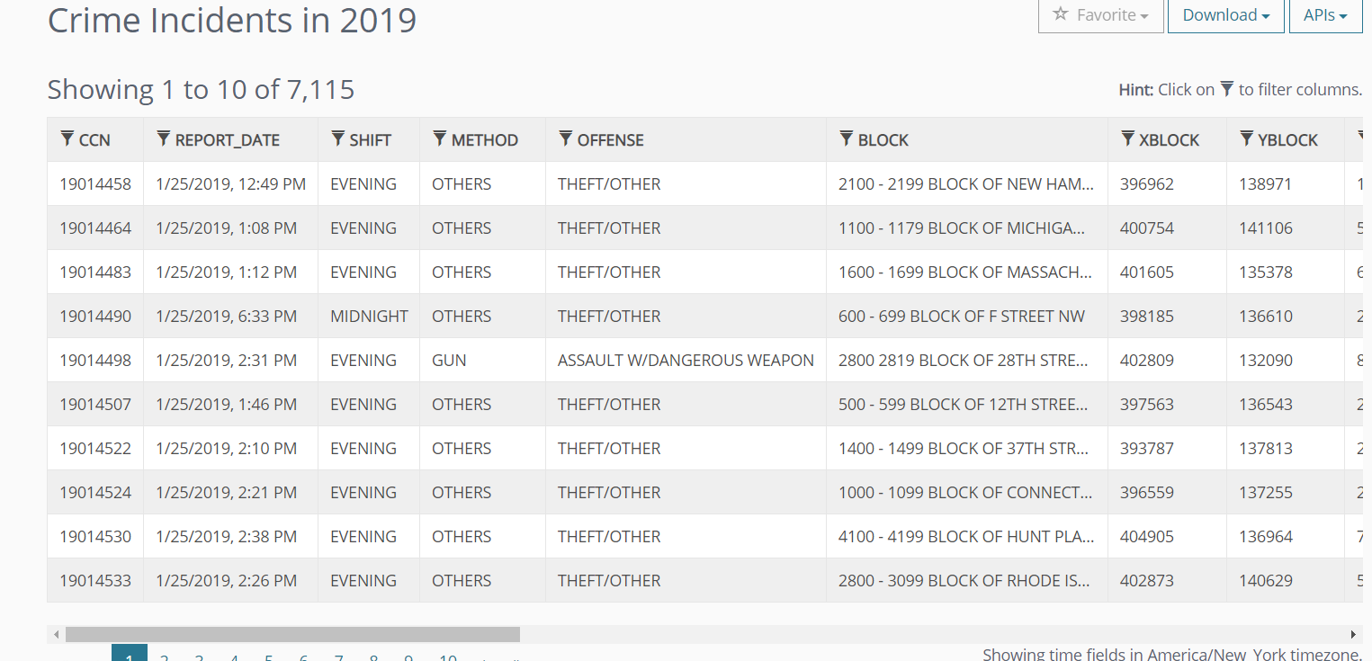

**3-4 Screenshots of relevant inspiring design:**

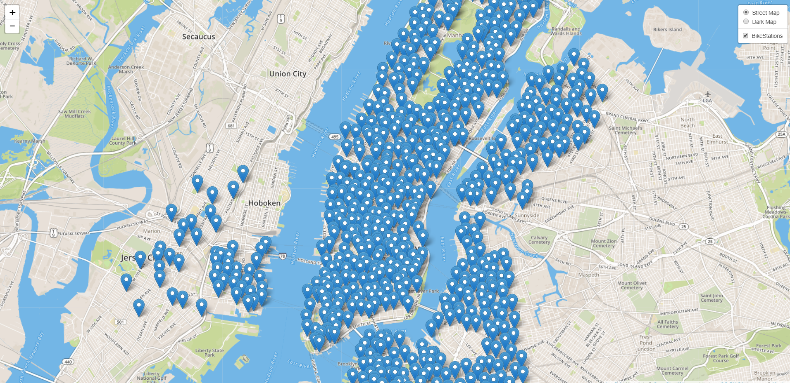

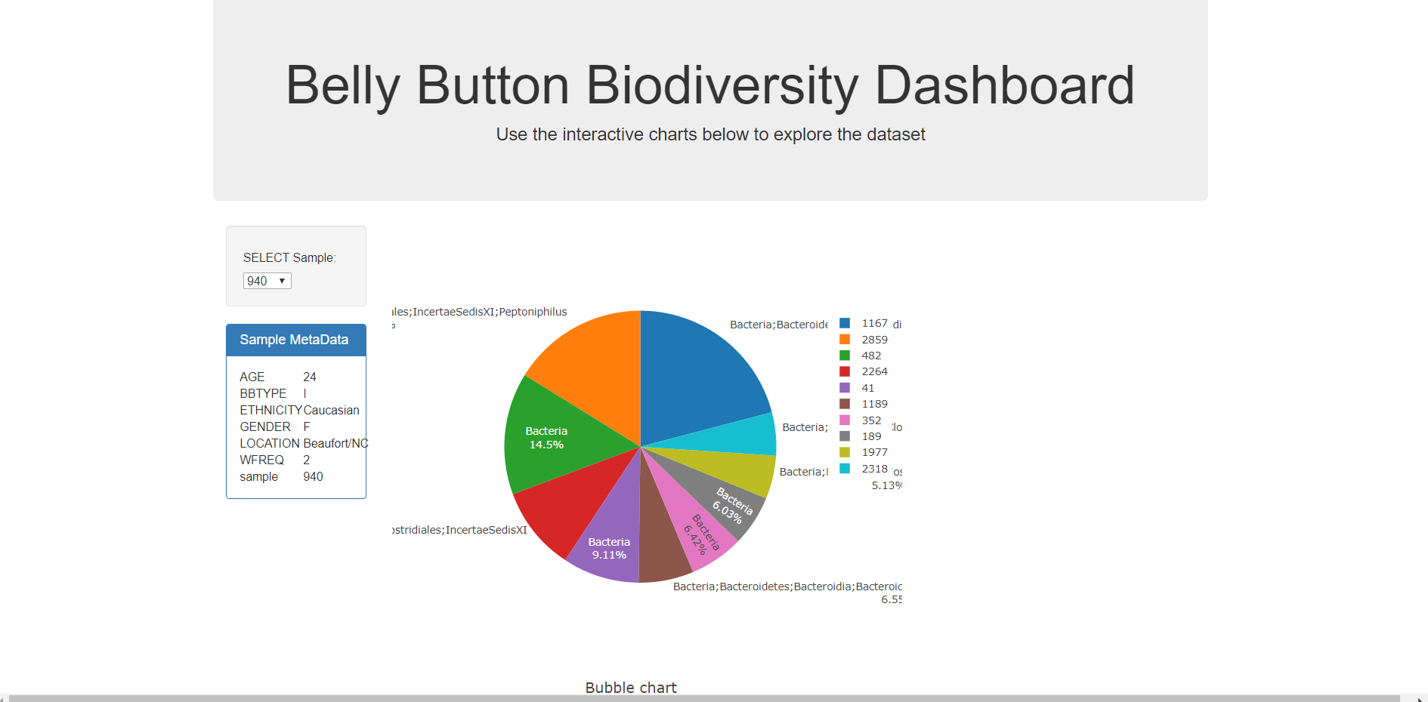

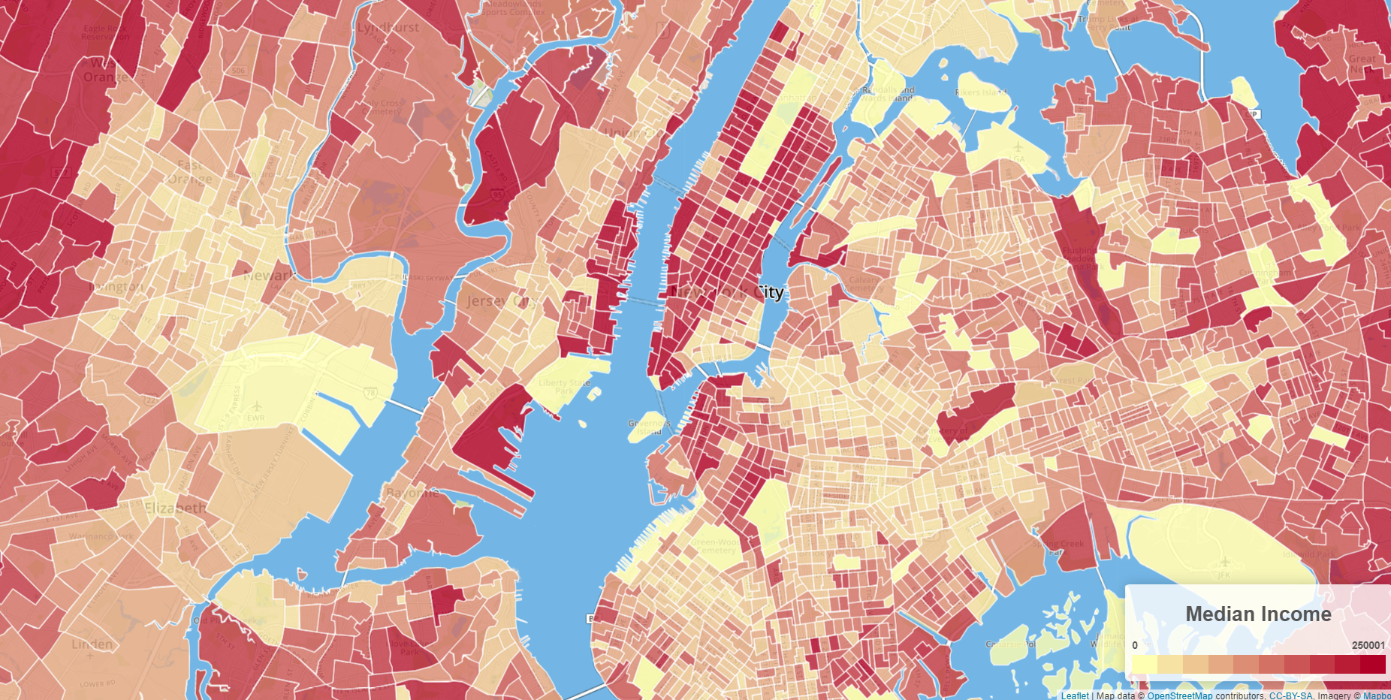

**Sketch of Final Design:**

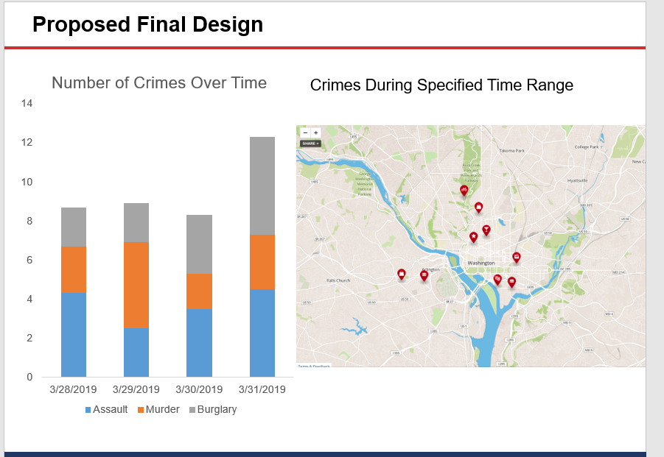

**Github Link**

<https://github.com/jpw24/project-3-team2>